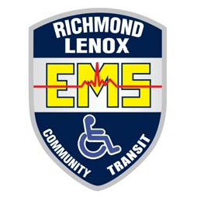
Richmond Lenox E.M.S.
Community Transit Wheelchair And Alternative Medical Transportation

(586)749-7713
Toll free: (844)666-5652

Richmond Lenox E.M.S. provides door to door transit for area residents needing transportation to and from medical appointments/procedures, banking, nutritional trips, or for work, personal business and to Detroit Metro Airport.
Our staff is trained in First Aid and CPR and will assist riders from their door to the vehicle and transport them safely to their destination. While there is no charge for our service, we do accept donations.

Rides may be scheduled up to six weeks before hand, and whenever possible with 72 hours advance notice. Transportation is provided on a first come first serve basis. Our service operates much like a public transit system and may involve picking up multiple riders going in the same direction near the same time. This type of routing provides us the necessary economies of scale to serve the greatest number of residents. This service model also necessitates riders remaining flexible when utilizing our service.
To Schedule an appointment please call 586-749-7713 OR toll free 844-666-5652, Monday thru Friday 9:00am to 3:00pm
Serving residents in Armada, Chesterfield, Lenox, Memphis, New Baltimore, New Haven, Ray, Macomb Twp and Richmond.
HOURS OF OPERATION AS OF AUGUST 2017

DAYS | FIRST PICK UP | LAST PICK UP | LAST DROP OFF
MONDAY-FRIDAY | 7:00 AM | 7:00 PM | 7:30 PM
SATURDAY | 9:00 AM | 11:30 AM | 1:00 PM

Airport Shuttle one trip daily to and from Detroit Metro Airport

DAYS | FIRST PICK UP | LAST PICK UP | LAST DROP OFF
MONDAY-SATURDAY | 5:00 AM | 7:00 PM | 9:30 PM
- Riders must be picked up 4 hours before their scheduled flight time.
- Riders are responsible for notify route dispatch center of any changes in their itinerary.
.

